

**SECOND FLOOR, 37A11, Sathy Rd, Saravanampatti, Siranandha Puram, Coimbatore, Tamil Nadu 641035**

**REF. NO: VET/AS/2025/22 Date: 16-08-2023**

**CERTIFICATE OF SPONSORSHIP FOR THE PROJECT**

**To**

**Dr.S.Christy,**

**Professor,**

**Department of Information Technology,**

**Saveetha School of Engineering,**

**Saveetha University,**

**Chennai – 602105.**

Dear Sir/Madam,

Sub: Sponsorship for your project services –Reg.

Based on the discussions you had with our technical team, we are pleased to sponsor your project to an extent of Rs.36,000/-. The project titled “**Enhancing the accuracy in predicting the Bus Travel Time using modified Linear Regression compared with Random Forest**” should be completed within a period of 6 months starting from 23/08/2023. Our requirements make it mandatory for you to submit a detailed project report to the sponsor and deploy the same in our premises.

Thanking you,

Yours truly,

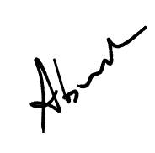  
**Gunasuriya C**

**Senior Technical Head,**

**Vee Eee Technologies Private Limited.**